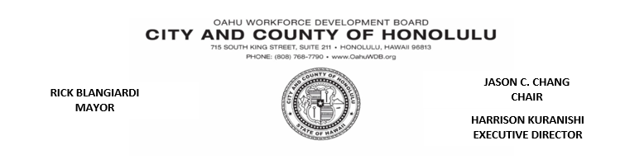

**FINANCE COMMITTEE MEETING**

**Wednesday, August 16, 2023**

**8:30 am – 10:00 am**

**MINUTES**

OWDB Members Present: Christopher Lum-Lee, Suzie Schulberg, Frederick Pascua, Carla Kobashigawa

Guests: Merton Chinen

OWDB Staff: Raymond Duong, Harrison Kuranishi

1. Call to Order…………………………………………………………………........................... Chair Chris Lum Lee

Chair Chris Lum Lee called the meeting to order at 8:32 a.m.

1. Welcome and Introduc………………………………………………………………….…Chair Chris Lum Lee

With only Board members present, no introductions were issued.

1. Approval of May 26th, 2023 Meeting Minutes

Chair Chris Lum Lee entertained a motion to approve the May 26, 2023 Finance Committee Meeting Minutes. Suzie Schulberg motioned to approve. Frederick Pascua seconded the motion. The minutes were unanimously approved.

1. PY2021 Expenditures

Raymond Duong shared the OWDB PY2021 Expenditures. The Adult Program is at 55% of the funds spent. The Dislocated Worker Program is at 57% of funds spent. The Youth Program is at 49% of the funds spent. The One Stop Operator is at 58% of the funds spent. The Rapid Response Program is at 55% of funds spent. Across all programs, there has been about a 5% increase in funds spent from March 2023 to April 2023. At the current spending rate, WIOA programs are projected to return about 28% of funds to the State of Hawaii.

1. PY2022 WIOA Contract Budget

The PY22 budgets still need to be approved. The State will approve the budget once an IFA/MOU is in place.

1. Outstanding Reimbursements

Raymond Duong went over the Outstanding Reimbursements for the previous program years. All outstanding invoices in PY21 must be re-submitted, subtracting the office rent since an MOU/IFA was not approved.

PY19 Reimbursements are due to Capital Expenditures. OWDB did not get prior approval, and these reimbursements may not be approved.

1. Discussion: Program Spending

Chair Chris Lum Lee opened the floor to discussion regarding how WIOA programs can spend more funds. Carla Kobashigawa spoke about assessments and other services being provided. An Industry feedback survey would help improve our services to the public. OWDB needs to communicate with successful programs to build a successful WIOA program.

The AJC must collaborate between partners and other state agencies to succeed. Chair Chis Lum Lee requests a spending plan for PY22 to keep the Service Provider accountable.

1. Announcements

There was no announcements or public testimony.

1. Adjournment…………………………………………………………………………………………Chair Chris Lum Lee

Chair Chris Lum Lee adjourned the meeting at 11:26 am.